英 語
For parents and children with foreign backgrounds
Ｎｕｒｓｅｒｙ Ｈａｎｄｂｏｏｋ
～About life at nursery and things to bring～

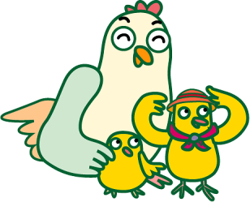

○○○ Ｎｕｒｓｅｒｙ
ＴＥＬ ○○○○（○○）○○○○

＊This handbook has been prepared to be used by nurseries where children with foreign backgrounds are enrolled. Please use the handbook by changing/adding words, the hours or the requirements to fit your nursery.
Kanagawa International Foundation

１. Eligible Ages
For children from ○○months old up to before enrollment to primary school
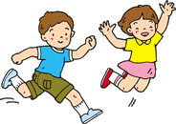
２. Enrollment Capacity
Enrollment Capacity ○○○○ Children

３. Nursery Care Hours （When the nursery is open）
◆Normal Nursery Care Hours→ ○○：○○ ～ ○○：○○
◆Extended Nursery Care Hours → ○○：○○ ～ ○○：○○（extra charge）
◆If your work requires you to bring your child to nursery on Saturdays also, please submit the Doyo Hoiku Shinseisho (Application for Saturday Child Care).
◆Please take care of your child at home when you are off from work.

４. Closures（When the nursery is closed）
◆Sundays/ Holidays and New Year Holidays（Dec. 00 ^{th} to Jan 00 ^{th}）
◆Special Occasions like Emergency Drills (Child collection drills) and others

５. Arrival and Collection （Arriving at and leaving the nursery）
◆The front door will be locked. Push the intercom, and state your name. The door will be unlocked as soon as we confirm your name.
◆Be sure that your child is always brought to and collected from the nursery by parent/guardian or by someone coming in place of the parent/guardian who can assume full responsibility.
Always inform the nursery when your child will be collected at a time other than the scheduled time or by a person other than the parent/guardian. We will not allow your child to leave if we are not notified of such changes.

◆Be sure to inform the nursery by ○○：○○, if your child will be late or absent.

TEL ○○○○－○○－○○○○

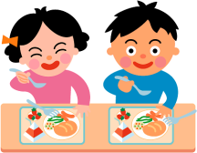
６. Meals
◆Infants under 1 year old →Milk (baby formula), bottles, baby food
Will be prepared to fit each child’s requirements
◆○ year olds →Rice, bread, or noodles; main dish (meat, fish or poultry with vegetables); snacks (morning/afternoon)
◆○ year olds and over →Rice, bread, or noodles; main dish (meat, fish or poultry with vegetables); snacks (afternoon)
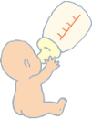
※If your child has food allergy, please go to a clinic for tests on allergen antibodies and be diagnosed periodically. Please submit the test results and the doctor’s instructions to the nursery. We will act according to the doctor’s instructions and test results. Please understand we cannot provide any elimination diet based on the parent/guardian’s instructions.

７. Clothing （What to wear）
◆Please prepare clothes that are fit to move around in and that your child can dress and undress by him/herself.
◆Please make sure your child has enough spare clothes to change at the nursery. (Make sure that you mark them with your child’s name)

８. Naps （Taking naps at nursery）
◆０year olds → Will take naps in accordance to their development
◆○year olds → Will take naps throughout the year
◆○year olds → Will not take naps during ○～○
◆The nursery will rent out mattresses. Please prepare blankets and such. Bed sheets are sold at the nursery.（○○○○yen）
Size of mattress ○○cm x ○○cm

９. Toilet Training （From diapers to underwear pants）
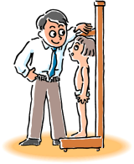
◆ We believe that the various issues related to toilet training are very important. We try not to push the children and place emphasis on the individual child’s status in promoting toilet training.

１０. Health （Physical conditions）
◆Measuring height and weight → ○○○times a month / year
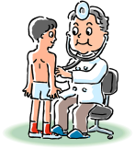
◆Health and Dental Check-ups → ○○○times a year
◆Threadworm inspections → ○○○times a year
◆We cannot take care of your child when he/she has a fever or doesn’t feel well. Be sure to always check your child’s health condition in the morning.
◆In case of illness or when an illness is suspected during nursery hours, our nursery, as a general rule, will contact the parent/guardian. We may ask you to come collect your child depending on the symptoms.
◆If your child is suffering from an infectious disease, your child cannot come to nursery until he/she has completely recovered. After full recovery, please ask your doctor to fill in a Toen Kyokasho (Approval to Attend Nursery) and submit it to the nursery
＊Infectious Disease: influenza (flu), pertussis (whooping cough), measles, tuberculosis (TB), mump and others.
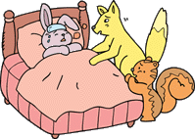
◆If your child needs to be administered medicine at nursery, the staff will accept and administer medication only prescribed by a doctor.
・For any liquid medications, be sure to put just one dose in a separate container.
・Mark the pouch or container of the medicine with your child’s name.
・Fill in required information in the Parent Communication Sheet at the registration desk（８：００～）（each day）. If there is a Yakuzai Jyouhou Teikyousho (Information on Medication Administration), please attach it.
・Always check your child’s nails and make sure they are cut.
（Children may scratch their own faces or may hurt other children with their nails）
・Be sure your child always eats breakfast before attending nursery. Breakfast is the source of power for the whole day.

１１. Injuries in the Nursery
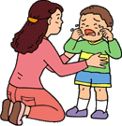
◆In case a child is injured during Nursery Care hours and requires medical treatment, the staff may take the child to a medical facility for treatment upon contacting the child’s parent/guardian. This nursery is insured to cover any such accidents.
Insurance Policy：○○○○○ Insurance

１２. About Safety
This nursery has cameras installed for security objectives.
An emergency call unit directly linked to 110 (police) is also installed to be used in times of emergencies.

１３. Miscellaneous
◆Be sure to inform the nursery immediately if there is any change in the address or telephone numbers of the parent/guardian’s workplace, home or cellphone.
◆Tuition payment shall be made by electronic transfer from the parent/guardian’s bank account (transfer on the last day of each month).
※In case the transfer was not made, a tuition collection envelope will be provided later from the nursery. Payments in cash should be placed in this envelope and made directly to the nursery.
◆Extended Nursery Care fees/ individual educational material costs/ Parents/Guardians Association fees / meal costs and other costs will be electronically transferred from the Japan Post Bank (YUCHO GINKO) account
Date of Transfer：○○ every month
If you do not hold an account with Japan Post Bank, please open one.
◆Please wash and return all clothes borrowed from the nursery at an early timing.
◆If you will be collecting your child by car, please use the designated area of the nursery for arrival and collection.
◆If you will be coming to the nursery by bicycle or on foot, please use the nursery’s front entrance when coming to and leaving the nursery.
◆Please put your bicycle in the designated bicycle parking space, out of the way of cars.
◆Please be sure to close the gates to prevent children from jumping out onto the street, upon coming to and leaving the nursery.
◆Be sure to read all handouts and postings at the nursery such as letters from the nursery, lunch menus, and others.
◆Do not let your child bring toys or food from home.
◆We ask that you refrain from calling nursery staff on the telephone as much as possible during nursery hours.
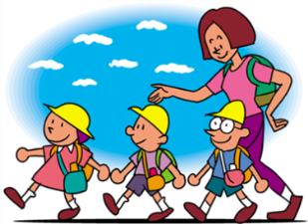
◆In case of emergencies, we may not be able to contact you by cellphones. Be sure to provide us with the number of a fixed telephone where we can surely contact you.

A Day at Nursery

１・２ year olds | Time | ３・４・５ year olds
Nursery Opens  Arrive at Nursery  Fun time | ７：００  ↓ | Nursery Opens  Arrive at Nursery  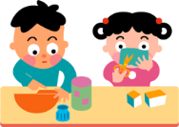  Fun time
Exercises using radio  program | ９：００ | Exercises using radio program
Snacks | ９：１５ | Morning Meeting
Play indoors/outdoors | １０：００ | Play at each play area
Lunch | １１：００ | Lunch
Nap time | １２：３０ | Nap time（○○year olds）  Fun time（○○year olds）
Snacks | １５：００ | Snacks
Fun time | １６：００ | End of the Day Meeting
Leave with  parent/guardian | １７：００ | Leave with parent/guardian
Extended Nursery Care  （extra charge） | １８：００ | Extended Nursery Care  （extra charge）
Snacks | １８：３０ | Snacks
Nursery Closes | １９：００ | Nursery Closes

◆The above shows a basic time schedule which will change accordingly.
◆For infants under 1 year, care will be provided in accordance to each child’s condition.

Things to Bring
 | 0 year olds | 1･2year olds | 3 year olds | 4･5 year olds
Change of clothes
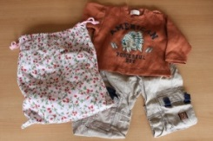
Set of clothes /
underwear/socks・
Clothes Bag
Bag size40㎝×50㎝
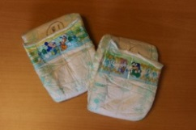
Diapers
Write the child’s name
on them
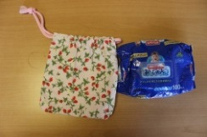
Wipes
Put wipes in a pouch

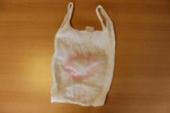
Plastic Bags
Write the child’s name
and always place some
plastic bags inside the Clothes Bags
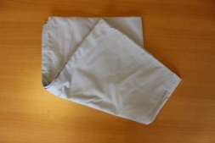
Bed sheets
Sold at nursery
127㎝×72㎝
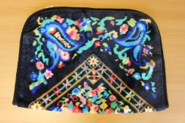
Blankets
Please adjust
for each season
Pajamas
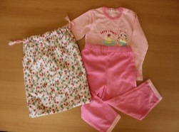
Easy to dress and
undress pajamas
Pajama Bag
35㎝×40㎝
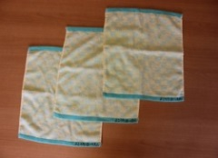
Wash cloth/ towel
Towels to be used moistened

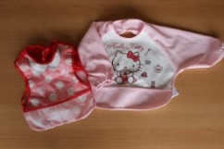
Apron
As needed

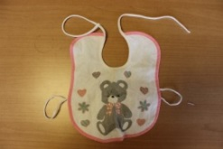
Bibs
As needed

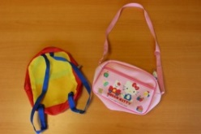
Child’s bag
Shoulder bags/knapsacks

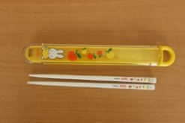
Chopsticks and spoons
Depending on the menu

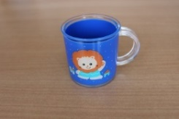
Cup
Cup resistant to heat
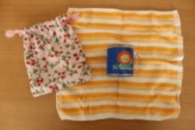
Dish-cloth
To wrap cups in
Bag Big enough to put
a cup and a set of chopsticks in.
Indoor shoes
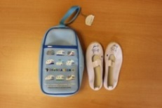
White indoor shoes something
like ballet shoes, etc.
Bag for indoor shoes
Used when brining home indoor shoes
on weekends.to be washed
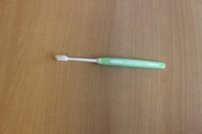
Tooth brush
Please replace as needed.
◆ The chart above is a guideline for the number of clothes necessary. Please feel free to adjust according to the season and your child’s development.
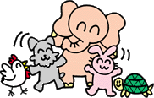
◆Take home all used diapers and dirty clothes every day.
◆Wash bed sheets and pajamas every week on weekends.

